Luz Deloria

**Wireshark – Lab 4_IP**

09/29/18

1. What is the IP address of your computer?

* The IP address of my computer is 192.168.1.233

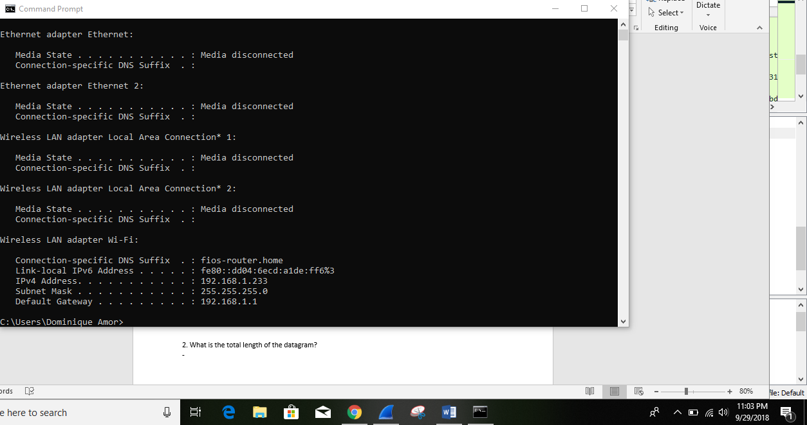

2. What is the total length of the datagram?

- The total length of the datagram is 466.

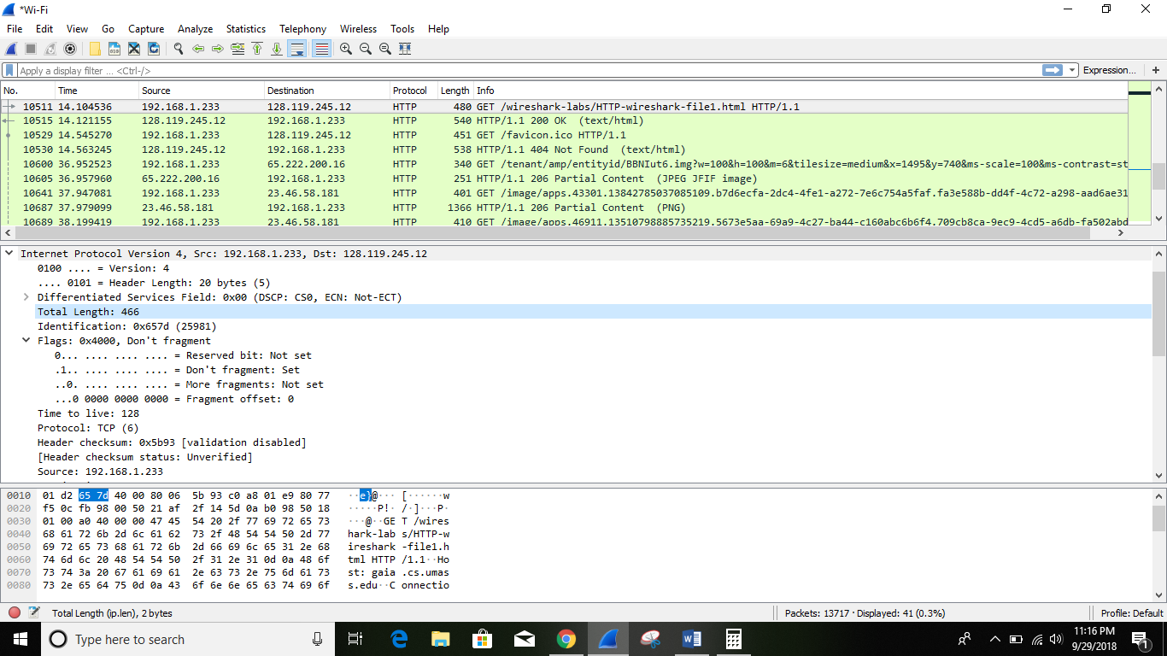

3. Has this IP datagram been fragmented?

- The fragments bit is = 0, so the data is not fragmented.

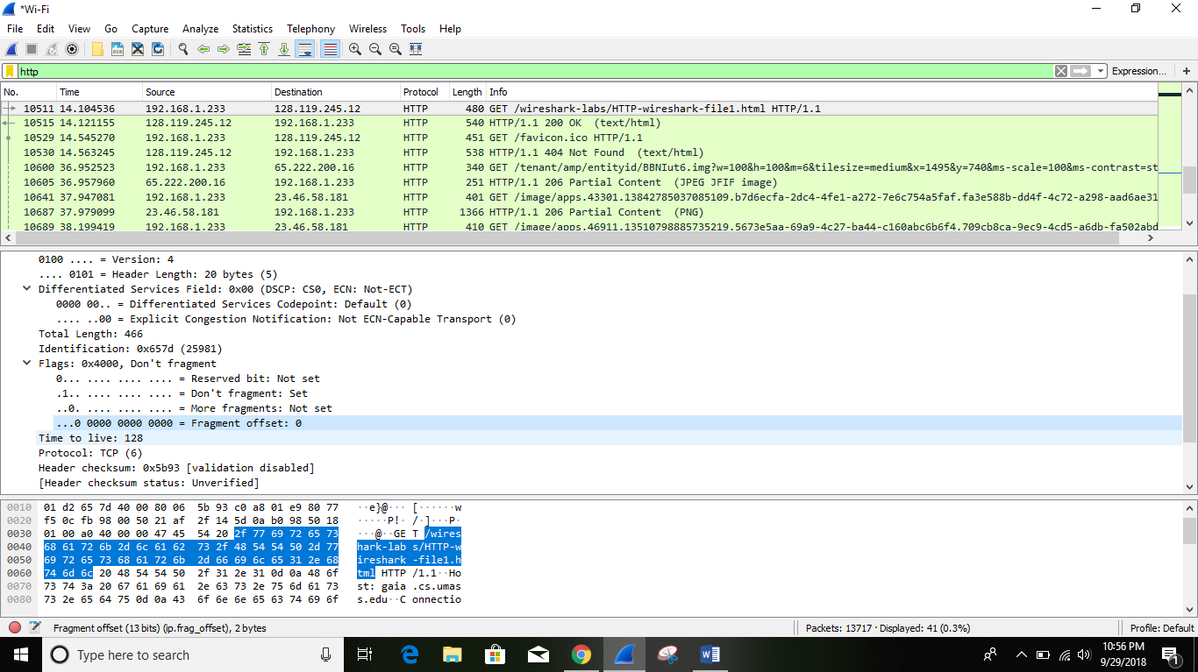

4. How many bytes are in the IP header?

-There are 20 bytes in the IP header.

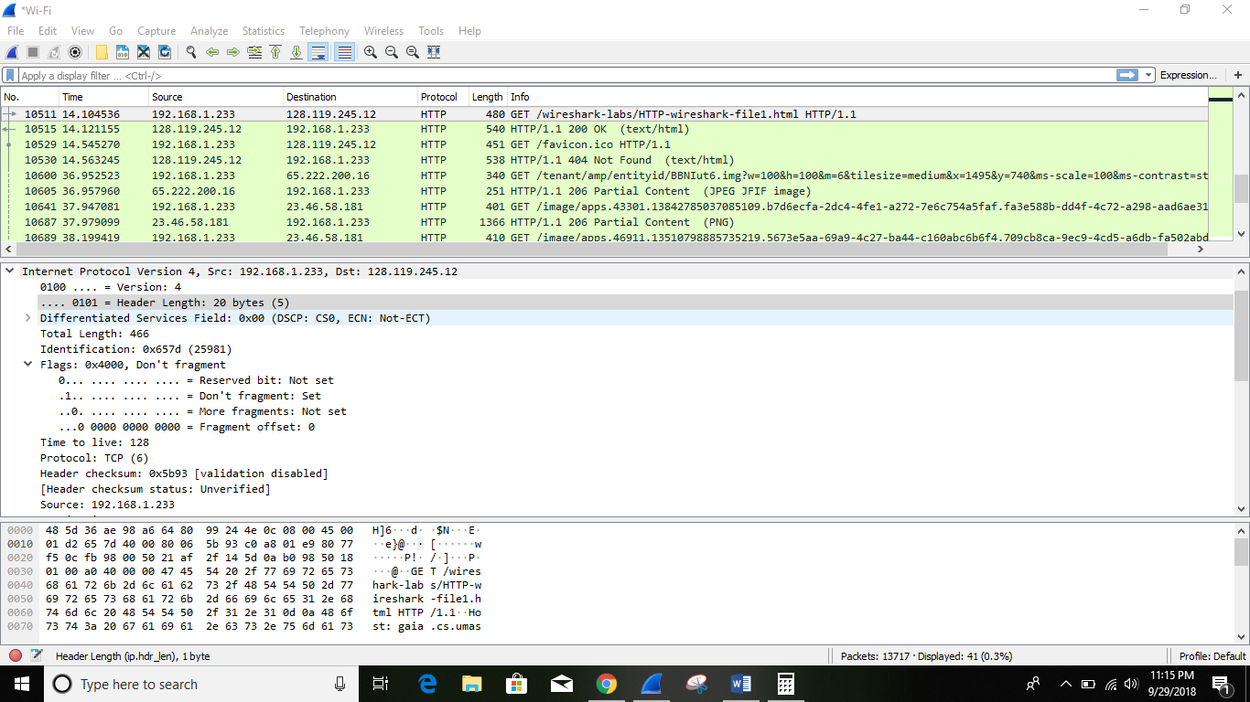

5. How many bytes are in the payload of the IP datagram? Explain how you determined the number of payload bytes.

-There are 20 bytes in the IP header, and 466 bytes total length, this gives 446 bytes in the payload of the IP datagram.

